EFRA

ASSOCIATE MEMBERSHIP

Manufacturer and Trading Companies
related to Model Car community

Dear Madam/Sir

The European Federation of Radio Operated Automobiles was originally established to promote the use of R/C Cars and to organize racing with the farther aim of promoting cooperation and friendship between countries. These are still very much our aspirations. Our target is also to keep as uniformed technical rules as ever possible within Europe.
Several manufacturers have taken the possibility to become Associate Members and with no doubt, as many new changes and improvement being made to various products related to the industry, EFRA requires input from the trade to continue into the future.
An Associate membership will be available to bona fide manufacturers of model racing cars as well as producers of equipment linked to the model car industry.
Associate members may be invited to speak at all EFRA General meetings and will be notified in advance of all details of proposed constructional rule changes. They have the rights to place proposals regarding constructional rule changes on a General meeting or Section conference agenda but carry no voting rights.
Further details connected to EFRA Associate Membership could be found in connection with the EFRA Associate Membership Application Form. Note that there is a new price list for the benefit of Associate Members.
On behalf of the Executive of EFRA is it my honour to invite your Company to join the Federation as an Associate member; in the case you already are a member, to re-join for the year 2019.
My deepest thanks to those members who have continued their support throughout the years. Attached you will find an application form which I hope you will complete and return to the secretary and the treasurer with your membership fee.
We are looking forward welcome you as an EFRA Associate Member 2019.

Best regards

Javier Garcia Jacqueline Aebi Willy Wuyts
President Treasurer General Secretary

EFRA

ASSOCIATE MEMBERSHIP

Additional Information

The Associate membership fee, to be determinate at the EFRA AGM, will be payable annually. Current Associate membership fee for 2019 is: €1000, 00.
Associate members have the right to advertise that they have an Associate Membership of EFRA, however wording such as "EFRA legal" cannot be used. The meaning could, in the case of a conflict, harm as well the manufacturer as the Federation EFRA.
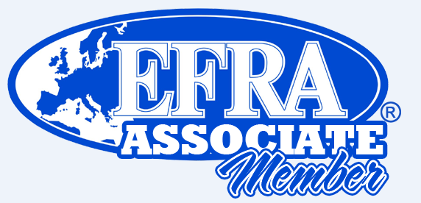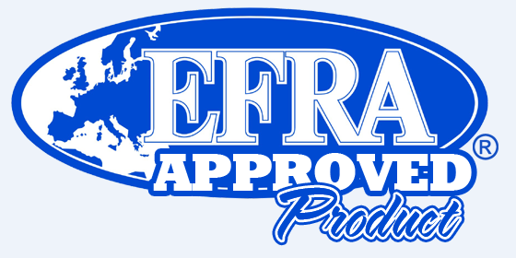
Any product that is a subject for EFRA Homologation or Approval procedure can, after receiving an EFRA Homologation or EFRA Registration number, be advertised as: "Complying with EFRA rules".
As an Associate Member of EFRA will you be informed of rule changes etc. via e mail or contact address you have specified of the EFRA Associate Membership Application Form.

FEES (ALL AMOUNTS QUOTED IN EURO)
Associate Membership is valid from the first of January 2019 until end of the year.
You will be informed in time for the next regular membership. Any new item already been submitted for homologation process/approval valid for the year 2019 will be refunded according to the price list below.
Subject | Fee | Qty | % | Ass. Member Fee
EFRA Associate Membership 2019 | 1’000.00 | 1 |  | 1’000.00
Registration Fees discount for EFRA Ass. Members | Fee | Qty | 50% | Ass. Member Fee
Registration fee Muffler (2 years period) | 120.00 | 1 | yes | 60.00
Approval 1/12 bodies (at the moment) | 0.00 | 1 |  | 0.00
Registration Motors | 50.00 | 1 | yes | 25.00
Homologation Fees discount for EFRA Ass. Members | Fee | Qty | 50% | Ass. Member Fee
Homologation fee Large Scale Bodies | 500.00 | 1 | yes | 250.00
Homologation fee Track 1/8 IC 1/10 IC Bodies | 500.00 | 1 | yes | 250.00
Homologation fee Track 1/10 Electric Bodies | 500.00 | 1 | yes | 250.00
Renewed Homologation: After 5 years a body will disappear from the list unless the manufacturer asks for a license for another period of 5 years. The fee for an extra period is 40% of the normal homologation fee. | 200.00 | 1 | no
Homologation fee Inlet silences (INS Boxes) | 800.00 | 1 | yes | 400.00
Homologation fee Inlet silences (INS Boxes) OEM | 0.00 | 1 | yes | 0.00
Homologation Battery | 500.00 | 1 | yes | 250.00
Additional benefits only for EFRA Ass. Members | Fee | Qty | 100% | Ass. Member Fee
Displayed on official website with Logo and Perimeters | - | - | yes | 0.00

EFRA

ASSOCIATE MEMBERSHIP

IMPORTANT NOTE:
EFRA logos etc. for publication will be published at the EFRA web www.efra.ws and in the benefits for the Associate Members your logo will be presented on an EFRA banner used at EC Championships.
The size must be W: 420mm H: 90mm resolution: 300dpi.
Preferably should it be a vector file (adobe illustrator or CorelDraw version 11 or higher).
If this is not possible, we would like to have the logo in eps format, as a last solution we could also accept jpeg format, but the size MUST be as mentioned above.
Please send your file(s) to each of these EFRA Officer: secretary@efra.ws.

For further info regarding the EFRA homologation/approval procedure please contact:
Body homologation for Track 1:8 IC, 1:10 IC, 1:10 & 1:12 Electric track:
Krist Bultynck: body.homologation@efra.ws
Body homologation 1:5 scales:
Craig Orman: largebody.homologation@efra.ws
Battery homologation:
Paul Worsley: battery.homologation@efra.ws
Motors homologation:
Paul Worsley: motor.homologation@efra.ws
Muffler and INS Box:
Sander De Graaf: muffler.homologation@efra.ws

EFRA

ASSOCIATE MEMBERSHIP

Additional Information

Handbook information:

General Rule

Membership
Associated membership
1 Associated membership is available to bona fide manufacturers of RC model goods against an
annual associated membership fee as published in the yearly EFRA handbook. Associated
membership is valid from January the first till end of December of the same year. An associated
membership carries no voting rights
2 Benefits and rights of associated members:
• Attend and participate to manufacturer meetings organised by EFRA
• Attend General meetings as observer
• Address the General Meeting subject to authorisation or invitation (a request stating the topic to
be sent to the General Secretary in writing in due time to be included in the agenda
• Place proposals regarding RC racing on the meeting or conference agendas.
• Participate to section meetings.
• Participation in workgroups or specific taskforces when invited to do so by EFRA
• Subject to authorisation by EFRA: expose products, without trading rights at meetings. A
nominal fee may be applicable and EFRA does not provide exposition accessories, stands
or furniture.
• Advertising by associated members of their membership to EFRA for marketing purposes is
allowed.
• Wordings such, as “EFRA Legal, accepted, preferred, recommended” cannot be used.
• As an associated member one can use the expression “Complying with EFRA rules” for
advertising and/or commercial purposes, but only for the very product that is approved.
• Non-authorised use of the mention “Complying with EFRA rules” or referring to EFRA otherwise
than described in this handbook may result in a ban of up to two (2) years for applications to
obtain approval of products in which case no refund or indemnities whatsoever will be granted.
• Unauthorised reference to EFRA by non-members is subject to a ban from approval or
becoming associated membership for three (3) years. No claims what so ever can be made
against EFRA in such case and EFRA retains sole rights to accept or refuse applications for
membership or approval of products at any time.
• Only products receiving EFRA approval or registration number can be advertised by the words
• Receive early notification about proposed constructional rule changes.
• One page advertising in the concerned section of the electronic (pdf) version of the EFRA
handbook. (Advertising of acceptable quality, pdf format A4 to be provided by the member)
• Being advertised as associated member on the EFRA website (appropriate company logo to be
provided)
• Being listed in the EFRA handbook as associated member (subject to the application being
received in due time).
• Considerable discounts on approval fees.

Special points for Tire manufactures in 1/8th and 1/10th 200mm IC cars:

• You are allowed to promote yourself as EFRA Official Tire Supplier.
• You will be provided with enough space on the track during EFRA EVENTS, to handle the Controlled Tire System.
• You can put banners on the track as EFRA Official Tire Supplier, with a maximum of 5 banners. If more banners on the track or another kind of advertisement is preferred, that will be done in agreement with the organizer.
• All benefits for EFRA Associated Members, as mentioned above.

EFRA

ASSOCIATE MEMBERSHIP

EFRA Associate Membership 2019

OUR APPLICATION IS: NEW A RENEWAL
Please tick the appropriate box
Company details:
Name:
Address:
Zip code: |  | Town:
Country: |  | Web:
Details of manufactured items (e.g. Cars, Motors, Batteries, Tires, Radios, etc.):
Contact details:
Phone No: |  | Mobile No:
Email: |  | Web:
Contact person:
This application has been authorised by:
Name: |  | Position:
If you scan this application please sign here:
PLEASE NOTE: Associate membership fee is one thousand Euro (€ 1000) per annum, payable each year.
Payment can be made directly by International Money Transfer to:
Account holder: | EFRA, European Federation of Radio operated model Automobiles
Address: | Rödhakestigen 1, 605 98 Norrköping Drottninggatan
Bank address: | HANDELSBANKEN Branch N 6591 NORRKÖPING DROTTNINGGATAN, Sweden
IBAN: | SE 21 6000 0000 0000 4320 2799
Swift code: | HANDSESS
Please do not use Company cheque for payment, as high charges are deducted through bank.
Also specify AT NO COST FOR BENEFICIARY.
Please notify EFRA Treasurer treasurer@efra.ws when payment has been made and return completed membership form or advise all details to: secretary@efra.ws in electronical form, thank you.

